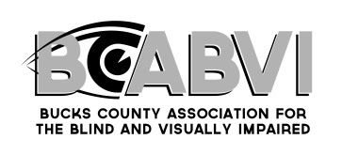

**Scheduling a Low Vision Appointment**

Dr. Denise T. Wilcox OD, PhD

400 Freedom Drive Newtown, PA 18940

800 West State Street Suite 301 Doylestown PA 18901

* To schedule an appointment call 215-968-1035.
* Please have the following information available when you call
  + Patient Name and Date of Birth
  + Cause of Vision Loss
  + Current or Referring Eye Doctor, including practice name, physician name, location of the practice and practice phone number
  + Insurance Information
* Before your appointment, you will be mailed paperwork including
  + An appointment card with the date and time of your appointment
  + A **Patient History Medical Form** that you must complete and bring with you the day of your appointment.
* We will give you a reminder call 24-48 hours ahead to confirm your appointment

* We ask you arrive 15 minutes before your appointment with your completed paperwork, insurance card and any glasses/low vision devices you currently use.
* Low Vision Evaluations last approximately 90 minutes. Follow up appointments are scheduled for 45 minutes. Please schedule transportation accordingly and plan for any additional needs (ie. if you are diabetic, bring a snack with you)